**Project Design Phase-II**

**Technology Stack (Architecture & Stack)**

|  |  |
| --- | --- |
| Date | 20 June 2025 |
| Team ID | LTVIP2025TMID55634 |
| Project Name | Booknest: Where Stroies Nestle |
| Maximum Marks | 4 Marks |

**Technical Architecture:**

This deliverable should feature a comprehensive architectural diagram, along with supporting information as detailed in Table 1 and Table 2.

**Example: Booknest is built using a 3-tier architecture**

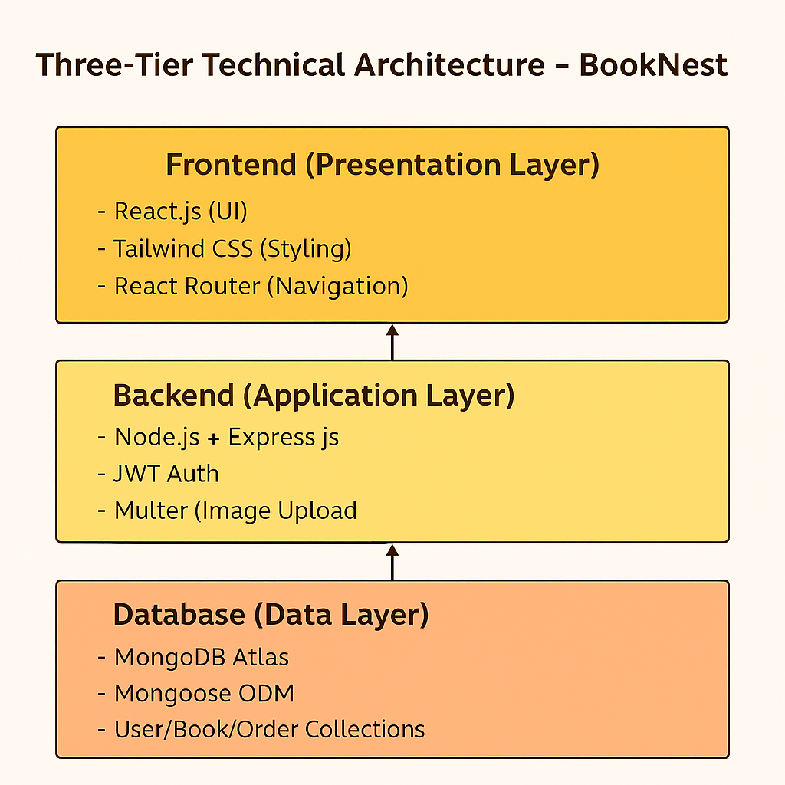

**Table-1 : Components & Technologies:**

|  |  |  |  |
| --- | --- | --- | --- |
| **S.No** | **Component** | **Description** | **Technology** |
| 1 | User Interface | Web UI for user interaction | HTML, CSS, JavaScript, React.js, TailwindCSS |
| 2 | Application Logic-1 | Authentication & Routing Logic | Node.js, Express.js |
| 3 | Application Logic-2 | Wishlist, Cart, and Admin logic | Express.js Controllers |
| 4 | Application Logic-3 | Book CRUD and filtering system | Express.js Controllers |
| 5 | Database | Document-oriented storage | MongoDB |
| 6 | Cloud Database | Hosted MongoDB database service | MongoDB Atlas |
| 7 | File Storage | Book image upload | Multer, Cloudinary / Local FS |
| 8 | External API-1 | Image storage or metadata (if used) | Cloudinary API |
| 9 | External API-2 | Not used | — |
| 10 | Machine Learning Model | Not used | — |
| 11 | Infrastructure | Cloud/Local Deployment | Local Server (Node), MongoDB Atlas (Cloud) |

**Table-2: Application Characteristics:**

|  |  |  |  |
| --- | --- | --- | --- |
| **S.No** | **Characteristics** | **Description** | **Technology** |
| 1 | Open-Source Frameworks | Open-source tools used in development | React.js, Node.js, Express.js, MongoDB |
| 2 | Security Implementations | Access control, token-based auth | JWT, Bcrypt.js, Helmet.js, CORS |
| 3 | Scalable Architecture | 3-tier scalable design with modular services | MERN Stack |
| 4 | Availability | Hosted backend, database in cloud (MongoDB Atlas), supports 24/7 uptime | Cloud-hosted MongoDB Atlas, Node Server |
| 5 | Performance | Optimized queries, component-based frontend, fast API responses | React Virtual DOM, REST API, MongoDB Indexes |